# Section 5: The Greatness of the Buddha

The Blessed One, the Fully Awakened Buddha, was a being of boundless wisdom, immeasurable compassion, and unfathomable spiritual power. His supreme enlightenment illuminated the world, dispelling the darkness of ignorance and offering the path to liberation for countless beings.

The greatness of the Buddha is beyond thought, beyond words, beyond limits. He is the supreme refuge, the incomparable guide, and the most exalted being to ever walk the earth.

In this section, we shall recount some of the most remarkable events in his life—profound moments that reveal his extraordinary wisdom, boundless compassion, and the unparalleled greatness of his awakening.

# The Buddha’s Supreme and Noble Qualities

In the earlier sections, we saw how the Buddha, with his unmatched wisdom and unwavering determination, overcame Māra’s tenfold army and attained the supreme enlightenment of a Sammāsambuddha. Now, we will highlight the extraordinary qualities he perfected upon reaching this ultimate state of awakening.

The Buddha possessed unparalleled virtues that no other being in the three worlds could equal. As a Sammāsambuddha—one who rediscovers and proclaims the timeless Path to Enlightenment—he attained a vast range of exceptional powers and supreme knowledges. While some of these were also realized by his noble disciples, there were certain higher wisdoms and insights that only a Fully Enlightened One could possess. [1] His supreme qualities set him apart as the greatest of all beings, a beacon of wisdom, compassion, and boundless liberation.

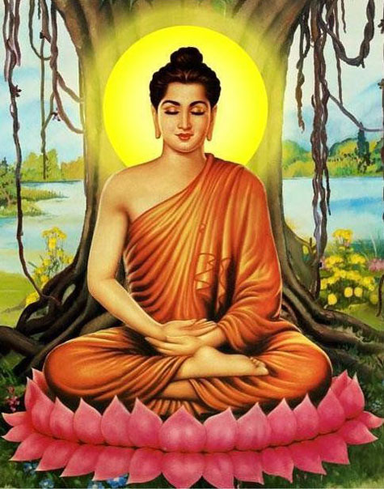

**The Fully Enlightened Buddha [2]**

## The Inconceivable Greatness of the Buddha

The supremacy of the Blessed One is beyond measure—so profound and vast that only another Buddha could truly comprehend the depth of his wisdom, knowledge, and spiritual attainments. The Buddha’s enlightenment is not something that can be grasped by ordinary minds; it transcends all human and celestial understanding. As the following sutta states:

*“The domain of the Buddhas is an inconceivable matter that one should not try to conceive; one who tries to conceive it would reap either madness or frustration.” [3]*

## No One in the Three Worlds Can Rival the Buddha

Just as a lion—the king of beasts—stands unsurpassed among all animals, so too does the Blessed One reign supreme in the world, beyond comparison with devas, humans, or any other beings. As the Fully Awakened One, he set in motion the great Wheel of the Dhamma, also known as the Brahma Wheel, which no one else could turn. His teachings, pure and luminous, were offered for the welfare and liberation of all sentient beings.

The following verses illustrate the Buddha’s unparalleled greatness:

"He is the Blessed One, the Buddha,  
He is the lion, unsurpassed;  
In this world with its devas,  
He set in motion the wheel of Brahma.

Thus, those devas and human beings  
Who have gone for refuge to the Buddha  
Assemble and pay homage to him,  
The great one, free from diffidence.

Tamed, he is the best of tamers;  
Peaceful, he is the seer among peace-bringers;  
Freed, he is the chief of liberators;  
Crossed over, he is the best of guides across." [4]

Indeed, beings of the three worlds—whether humans, devas, or Brahmas—revere the Blessed One, for there is no one who can rival his boundless wisdom, his perfect compassion, and his supreme realization.

The Buddha, out of his infinite compassion, tirelessly shared his teachings, offering the path to liberation without holding anything back. He is honoured by gods and humans alike, for he is the foremost among all beings, the one who has transcended the cycle of birth and death:

"The Realized One, compassionate for all living creatures,  
Unstintingly offers teaching.  
Sentient beings revere him, first among gods and humans,  
Who has gone beyond rebirth." [5]

# The Buddha’s Profound and Extraordinary Knowledge

Upon attaining perfect enlightenment, the Buddha realized special abilities unique to a Sammāsambuddha. These supreme insights, known as the Ten Tathāgata Powers, granted him unparalleled understanding of reality. With these extraordinary powers, the Blessed One rightfully assumed the position of the supreme teacher, fearlessly proclaiming the Dhamma and turning the Wheel of Brahma—a turning that no other being could accomplish.

As the Buddha declared: [6]

*“Sāriputta, the Tathāgata possesses these ten Tathāgata powers. With them, he claims the place of the herd leader, roars his lion’s roar in the assemblies, and sets rolling the Wheel of Brahma…”*

## The Ten Powers of the Tathāgata

1️. **Perfect Discernment of Reality** – The Buddha understands, as it truly is, what is possible and what is impossible. (He possesses the power to distinguish absolute truth from falsehood.) [7]

2️ **Knowledge of Kamma and Its Results** – The Buddha comprehends the workings of kamma—past, present, and future—along with the causes and consequences of all actions. [8]

3️ **Insight into the Destinies of Beings** – The Buddha perceives the various paths leading to different realms of existence and knows where beings will take rebirth, whether in higher or lower states. [9]

4️ **Understanding the Diverse Elements of the World** – The Buddha sees the world as it truly is, in all its various and intricate aspects.

5️ **Insight into the Inclinations of Beings** – The Buddha understands the varying tendencies of beings, recognizing that some have noble inclinations while others have inferior ones, and that individuals are drawn toward like-minded company.

6️ **Knowledge of the Faculties of Beings** – The Buddha perceives the strength and weaknesses of beings in terms of their faculties of faith, energy, mindfulness, concentration, and wisdom. [10]

7️ **Mastery Over Mental Attainments** – The Buddha fully understands the arising, purification, and transcendence of mental states, including the jhānas, liberations, deep samādhi, and higher attainments. [11]

8️ **Recollection of Past Lives** – The Buddha recalls his own past lives in countless detail, seeing the vast cycle of his past existences. [12]

9️ **The Divine Eye (Dibba-Cakkhu)** – The Buddha, with his purified and superhuman vision, sees beings passing away and being reborn according to their kamma—whether they are fortunate or unfortunate, noble or base, radiant or dark. [13]

10 **Unshakable Liberation** – By his direct realization, the Buddha abides in perfect liberation of mind and wisdom, completely free from all taints and defilements, having utterly destroyed them.

These supreme knowledges of the **Tathāgata** are beyond the reach of any other being in the three worlds. With these unparalleled insights, the Buddha illuminated the path to liberation, guiding countless beings from suffering to the bliss of Nibbāna.

### The Six Unshared Supernormal Knowledges of the Buddha

Among the vast range of supreme knowledges possessed by the Buddha, there are six extraordinary insights that no noble disciple can attain. These unique abilities, known as asādhārana ñāna (unshared knowledge), belong exclusively to the Sammāsambuddha and further distinguish his incomparable wisdom. They are:

1️ Knowledge of the Maturity Levels of the Five Spiritual Faculties (*Indriya-Paropariyatta Ñāna*) – The Buddha perceives, with perfect clarity, the varying degrees of development in beings' faculties of faith, energy, mindfulness, concentration, and wisdom. [14]

2️ Knowledge of the Dispositions and Underlying Tendencies of Beings (*Āsayanusaya Ñāna*) – The Buddha fully understands the subtle inclinations and latent tendencies of all beings, seeing their deep-seated habits and potential for spiritual progress. [15]

3️ Knowledge of the Twin Miracle (*Yamakapātihāra Ñāna*) – The Buddha alone possesses the ability to perform the Twin Miracle, simultaneously emanating flames from one part of his body and streams of water from another, demonstrating his mastery over the elements. [16]

4️ Knowledge of the Attainment of Great Compassion (*Mahā-Karuṇāsamāpattiya Ñāna*) – The Buddha enters and abides in the sublime state of boundless compassion, extending his infinite loving-kindness to all beings without exception. [17]

5️ Knowledge of Omniscience (*Sabbannuta Ñāna*) – The Buddha comprehends all things that are knowable, perceiving reality in its entirety, with nothing hidden from his all-encompassing wisdom. [18]

6️ Knowledge of Un-obstructiveness (*Anāvaraṇa Ñāna)* – The Buddha sees the universe without obstruction, perceiving all aspects of existence—past, present, and future—without limitation or hindrance. [19]

### A Unique and Supreme Wisdom

The *Patisambhidāmagga*, a revered text in the Theravāda tradition, describes seventy-three kinds of knowledge possessed by the Buddha. Of these, sixty-seven are shared with his noble disciples, while the six asādhārana ñānas listed above remain exclusive to the Tathāgata.

These supreme knowledges further illuminate the Buddha’s unsurpassed wisdom, limitless compassion, and absolute mastery over all phenomena, qualities that set him apart as the greatest being to ever arise in the three worlds.

# The Nine Supreme Noble Qualities of the Buddha

The virtues of the Blessed One are beyond measure—his wisdom, purity, and compassion shine like the sun, illuminating the path for all beings lost in the darkness of suffering. The scriptures speak of countless noble qualities of the Buddha, but among them, nine stand as the most revered, encapsulating his incomparable greatness. These qualities are not merely words of praise; they are a source of profound inspiration. The Buddha himself declared that reflecting upon his noble qualities brings deep peace and harmony to the mind.

The Buddha said this to Mahānāma sakyan:[20]

“…you should recollect the Tathāgata thus”*: [21]*

*The Blessed One is an Arahant, [22] perfectly enlightened,* ***[23]*** *accomplished in true knowledge and conduct,* ***[24]*** *fortunate,* ***[25]*** *knower of the world, [26] unsurpassed trainer of persons to be tamed,* ***[27]*** *teacher of devas and humans,* [28] *the Enlightened One* ***[29]***

*the Blessed One…”[30].*

A detailed description of these qualities is given in section:4 of this series

These supreme qualities are traditionally expressed in Pāli as:

*“Araham sammā-sambuddho, vijjā-caraṇa-sampanno, sugato, lokavidū, anuttaro purisa-damma-sārathi, satthā deva-manussānaṃ, buddho, bhagavā.”*

This means:

* Araham – The Perfected One, free from all defilements and worthy of veneration.
* Sammāsambuddho – The Fully Enlightened One, who discovered the ultimate truth by himself.
* Vijjā-caraṇa-sampanno – Possessing supreme wisdom and impeccable conduct.
* Sugato – Sublime, one who has gone to the ultimate goal.
* Lokavidū – The Knower of Worlds, understanding all realms and the nature of existence.
* Anuttaro purisa-damma-sārathi – The Supreme Trainer of those who can be trained.
* Satthā deva-manussānaṃ – The Teacher of both gods and humans.
* Buddho – The Awakened One, who sees things as they truly are.
* Bhagavā – The Blessed One, endowed with infinite virtues.

Recollecting the Buddha’s Qualities Brings Peace and Liberation

The profound impact of recollecting the Blessed One’s supreme qualities is beautifully described in the suttas:

*“…When a noble disciple recollects the Tathāgata, at that moment his mind is free from lust, hatred, and delusion. His mind becomes serene, steady, and uplifted. Inspired by the Dhamma, he experiences joy. From joy arises rapture, from rapture comes tranquillity, from tranquillity comes happiness, and from happiness the mind naturally becomes concentrated. Such a noble disciple dwells in peace amidst a world of turmoil, unafflicted in a world full of affliction. Having entered the stream of the Dhamma, he cultivates unwavering recollection of the Buddha.” [31]*

The Blessed One is the supreme refuge, the one who unraveled the snare of death for the sake of all beings. He revealed the timeless Dhamma, the path to liberation, offering guidance not only to humans but even to devas. Those who see him and listen to his words are filled with faith and confidence, for he is the incomparable master of the path.[32]

“He who found, for the sake of all beings, release from the snare of death;  
He who revealed the Dhamma for the welfare of devas and humans;  
He in whom beings gain confidence upon seeing and listening to him;  
The one skilled in the path and what is not the path,  
The taintless one who has fully accomplished his task;  
The Enlightened One, bearing his final body,  
Is truly called a Great Man of great wisdom.”[33]

Thus, the Buddha stands beyond all comparison—the greatest being to ever walk the earth, the peerless teacher of gods and men, the embodiment of boundless wisdom and infinite compassion. Recollecting his supreme qualities is not just an act of devotion; it is a gateway to inner peace, unwavering faith, and the path to liberation.

# The Buddha: The Great Man of Supreme Wisdom

In a profound discourse, the brahmin Vassakāra, the chief minister of Magadha, engaged in a dialogue with the Blessed One, seeking to understand who truly embodies greatness and supreme wisdom. By the end of their discussion, Vassakāra himself recognized that no one surpassed the Buddha in wisdom and virtue, declaring him the Great Man of Great Wisdom.

In response, the Buddha spoke these inspiring words:[34]

*“Indeed, I practice for the welfare and happiness of many. I have guided countless beings onto the noble path, establishing them in the goodness and wholesomeness of the Dhamma. My mind is completely mastered—I think only what I choose to think, and I do not think what I do not wish to think. I intend only what I choose to intend, and I do not intend what I do not wish to intend. Thus, I have attained complete mastery over my thoughts. At will, effortlessly and without difficulty, I enter and abide in the four jhānas, the deep meditative absorptions that elevate the mind and bring sublime peace in this very life. With the destruction of all defilements, I have directly realized, in this very life, the taintless liberation of mind and liberation by wisdom. Having attained this ultimate freedom, I now abide in it.”*

These words reveal the Buddha’s unparalleled mental mastery, his boundless compassion, and his complete liberation, distinguishing him as the unsurpassed teacher, the fully awakened one, and the supreme guide of gods and men.

# The Buddha: Honored and Revered by All Beings

The Blessed One was revered by all—humans, devas, and brahmins alike—yet he himself had no need to bow to anyone. The suttas reveal why the Buddha was the most honored being in all the worlds, standing supreme in wisdom, virtue, and liberation.

## The Buddha’s Supreme Status

In the *Verañjā Sutta* (AN 8:11), a brahmin from Verañjā approached the Buddha and questioned why he did not pay homage to elderly brahmins, stand up for them, or offer them a seat, saying:

*“Master Gotama, the ascetic Gotama does not pay homage to brahmins who are aged, burdened with years, and advanced in life. Nor does he stand up for them or offer them a seat… This is not proper, Master Gotama.”*

To this, the Buddha replied with unwavering confidence:

*“Brahmin, in this world with its devas, Māra, and Brahmā, among this population of ascetics and brahmins, devas and humans, I see no one to whom I should pay homage, stand up for, or offer a seat. For if the Tathāgata were to pay homage to anyone, stand up for him, or offer him a seat, even that person’s head would split.”*

These words illustrate the unparalleled supremacy of the Buddha, whose wisdom and realization far exceeded that of any being, whether human, celestial, or divine.

## The Buddha Honored the Dhamma

Even though no being in existence was worthy of receiving his homage, the Buddha himself sought something truly worthy of reverence. Soon after his enlightenment, as he reflected on whom he could honor and respect, he realized: *[35]*

**“***Now, what ascetic or brahmin can I honor, respect, and depend on? I see no other ascetic or brahmin, more perfect in knowledge and vision of liberation than myself, whom I could honor and respect, or on whom I could depend. Let me then honor, respect, and dwell in dependence on this very Dhamma to which I have fully awakened.”*

Thus, the Blessed One, supreme among all beings, honored not a person, but the timeless truth of the Dhamma, the very path of liberation that he had realized. His reverence for the Dhamma serves as a profound teaching for all beings—that true honor is not given to status or age, but to **wisdom, virtue, and the path to liberation**.

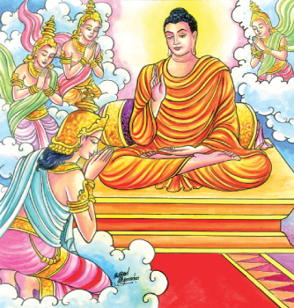

**Devas paying homage to the Buddha [36]**

## Celestial Beings Paying Homage to the Buddha

The Buddha’s supreme wisdom and boundless compassion inspired reverence not only among humans but also among the most powerful celestial beings in the universe.

In the *Vinaya Pitaka*, we find a remarkable account of the **Four Great Kings**, **Sakka, the King of the Devas**, and **Brahmā Sahampati** descending from their heavenly realms to **pay homage to the Blessed One** at Uruvelā Kassapa’s hermitage. These mighty deities, revered even among celestial beings, recognized the Buddha as the supreme teacher and the foremost guide of all worlds. [37]

Throughout the *Saṁyutta Nikāya*, numerous suttas—such as those in the **Devatā Saṁyutta, Devaputta Saṁyutta, Brahmā Saṁyutta, Sakka Saṁyutta, and Yakka Saṁyutta**—recount how **Devas, Brahams, Asuras, Yakkas, and other celestial beings** approached the Blessed One, paying their highest respects and seeking his profound wisdom.

Even the most exalted beings of the cosmos bowed before the Buddha, for they knew that no power, no divine radiance, no celestial authority could surpass the unshakable wisdom, perfect liberation, and boundless compassion of the Fully Enlightened One.

# The Buddha: The Most Senior and Supreme Being in the World

The scriptures describe the Buddha as the most senior, the foremost, and the eldest being in the world, not by age, but by wisdom, liberation, and his complete transcendence of birth and death.

In a profound teaching, the Blessed One declared:

*“…Brahmin, in a world immersed in ignorance—like an egg completely enclosed in its shell—I alone have pierced through the shell of ignorance. I am the only one in the world who has awakened to the unsurpassed perfect enlightenment. Thus, I am the eldest, the foremost, the highest in the world.” [38]*

## The Buddha: The True Elder of the World

The Buddha further explained the true meaning of seniority—not merely by years, but by the complete abandonment of birth and death, the perfection of the spiritual path, and the destruction of all taints: *”[39]*

“One who has transcended birth and death,  
Consummate in the spiritual life,  
In whom no defilements remain—  
He alone do I call an elder.”

Thus, the Blessed One, the Fully Enlightened One, the Supreme Teacher of devas and humans, is rightly honored as the most senior, the most venerable, and the greatest being in all existence.

# The Buddha is Skilful in All Three Deeds

The Buddha has mastery of deeds done by body, speech and mind. On one occasion remembering his past life as a king’s chariot-maker the Buddha said:

*“…then I was skilled in crookedness, faults, and defects in wood. But now I am the Arahant, the Perfectly Enlightened One, skilled in crookedness, faults, and defects of the body; skilled in crookedness, faults, and defects of speech; and skilled in crookedness, faults, and defects of mind…”[40]*

# The Buddha is the Most Excellent Speaker

The Buddha is the best of speakers because he speaks the Truth—the Dhamma his excellent words has helped many hundreds and thousands of beings from bondage.

*“Knowledge is the best of things that rise up;*

*Ignorance excels among things that fall down;*

*The Saṅgha is the best of things that go forth;*

*The most excellent of speakers is the Buddha”[41]*

# The Blessed One was the Arouser of the Unarisen Path

On one occasion the brahmin Gopaka Moggallāna, approached and asked Venerable Ānanda Thera:

“*Master Ānanda, is there any single bhikkhu who possesses in each and every way all those qualities that were possessed by Master Gotama, accomplished and fully enlightened?”*

Venerable Ānanda replied:

*“… There is no single bhikkhu, brahmin, who possesses in each and every way all those qualities that were possessed by the Blessed One, accomplished and fully enlightened. For the Blessed One was the arouser of the unarisen path, the producer of the unproduced path, the declarer of the undeclared path; he was the knower of the path, the finder of the path, the one skilled in the path. But his disciples now abide following that path and become possessed of it afterwards…”[42]*

# Wonderful and Marvelous Qualities of the Buddha

In Section 1 of this series, we have seen some of the wonderful and marvellous qualities of the Boddhisatva—the Buddha to be. In the scriptures there are innumerable places pointing out the wonderful and marvellous qualities of the fully awakened Buddha. We have selected a few suttas to elaborate on this point:

In the following sutta the Buddha says:

*“The Tathāgatas, Ānanda, are wonderful and possess wonderful qualities; the Tathāgatas are amazing and possess amazing qualities”[43].*

## The Buddha Possessed Numerous Psychic Abilities

The many psychic powers of the Buddha were called wonderful and marvellous qualities. These abilities varied: being many, he could become one; he appears and disappears; he passes through fences, walls and mountains unhindered as if through air; he sinks into the ground and emerges from it as if it were water; he walks on the water without breaking the surface as if on land; he flies cross-legged through the sky like a bird with wings; he even touches and strokes with his hand the sun and moon, mighty and powerful as they are; and he travels in the body as far as the Brahmā world.[44]

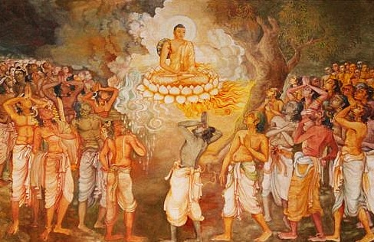

**Buddha’s Great Miracles [45]**

## Ability to Appear in the Brahmā World

At one time Venerable Ānanda approached the Blessed One and asked:

“*Venerable sir, does the Blessed One recall ever having gone to the Brahmā world by spiritual power with a mind-made body?”*

The Buddha replied:

*“When, Ānanda, the Tathāgata immerses the body in the mind and the mind in the body, and when he dwells having entered upon a blissful perception and a buoyant perception in regard to the body, on that occasion the body of the Tathāgata rises up without difficulty from the earth into the air. He wields the various kinds of spiritual power: having been one, he becomes many; having been many, he becomes one; … he exercises mastery with the body as far as the Brahmā world”[46]*

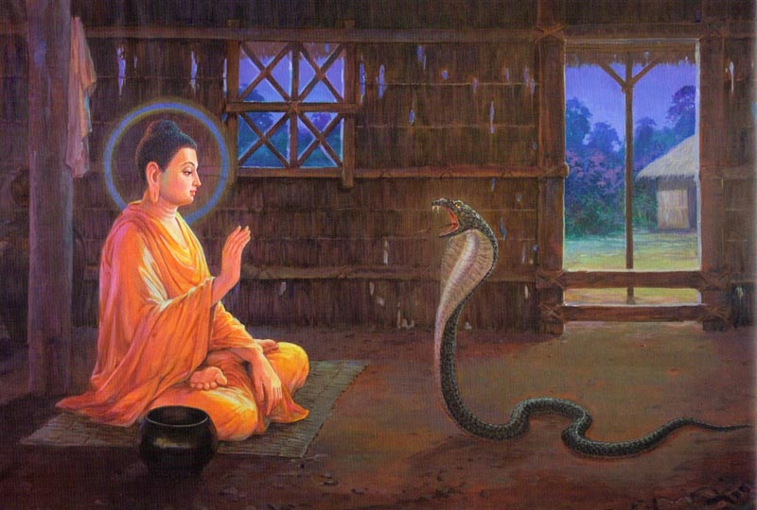

**Encounter with a Naga serpen**t [47]

## Performances of Miracle at the Monastery of Uruvela Kassapa

In the Vinaya Pitaka it describes [48] several performances of miracles by the Blessed One at the hermitage of Uruvelā Kasspa. It seems such events led to the conversion of Uruvelā Kassapa, a famous Jatila teacher at that time in Magadha and his two brothers, Nadī Kassapa, and Gayā Kassapa, who established faith in the Blessed One and became his disciples [49]. We have selected the following incident: an encounter with a Naga serpent—a venomous dragon king who lived in the ‘Fire Hut’ of Uruvelā Kassapa.

“*The Buddha entered the fire hut and prepared a spread of grass. He sat down, crossed his legs, straightened his body, and established mindfulness in front of him. When the dragon saw that the Buddha had entered, he was displeased and emitted smoke.”.*

The Buddha thought:

*“Let me overpower this dragon, using fire against fire, but without harming it in the slightest way…*”

The Buddha then used his supernormal powers so that he, too, emitted smoke. The dragon, being unable to contain his rage, emitted flames. The Buddha entered the fire element and he, too, emitted flames. With both of them emitting flames, it was as if the fire hut was ablaze and burning. The dreadlocked ascetics gathered around the fire hut, saying:

*“The Great Ascetic is handsome, but the dragon is harming him…”*

The next morning the Buddha had overcome that dragon, using fire against fire, but without harming it in the slightest way. He put it in his alms bowl and showed it to Uruvelā Kassapa:

“*Here is your dragon, Kassapa, his fire overpowered by fire*.” [50]

**Note:** Here we clearly see that the Buddha has shown his psychic power only on special occasions such as the taming of the serial killer Angulimāla and the great miracle he performed to break the pride of the Sakyas in the city of Kapilavastu.

## The Only Miracles the Buddha Approved

In Kevaddha Sutta (DN:11) the Buddha says this to the brahmin Kevaddha who urged the Buddha to perform miracles to gain the faith of people in the city of Nālanda.

“*Kevaddha, this is not the way I teach Dhamma to the monks, by saying:’ Go,*

*monks, and perform superhuman feats and miracles for the white-clothed lay-people…*

*…Kevaddha, there are three kinds of miracle that I have declared, having realised them by my own insight. Which three? The* ***miracle of psychic power,*** *[51] the* ***miracle of telepathy [52]****, the* ***miracle of instruction…[53]****”*

The Blessed One then warns Kevaddha that the miracle of psychic power and the miracle of telepathy have many dangers, hence he dislikes, rejects and despises them. The only miracle the Blessed One approved of was the miracle of instruction—the ability to transform a person through teaching the Dhamma; when one follows the teaching ardently, one can realise the truth for oneself.

## Noble Qualities are the True Wonders

The following stanza is the way the Buddha called attention to the quality he regarded as a true wonder and marvel [54]

*“…Ānanda, remember this too as a wonderful and marvellous quality of the Tathāgata: Here, Ānanda, for the Tathāgata feelings are known as they arise, as they are present,*

*as they disappear; perceptions are known as they arise, as they are present, as they disappear; thoughts are known as they arise, as they are present, as they disappear. Remember this too, Ānanda, as a wonderful and marvellous quality of the Tathāgata.”[55]*

# The Signs of the Great Man

It is shown in the scriptures that the Buddha had not only great spiritual qualities but also extraordinary physical features. The Lakkhaṇa Sutta (DN:30) outlines the thirty-two physical attributes of the Blessed One [56]

In the following sutta shows who is the great man who possesses the thirty-two signs.

*“There are, monks, these thirty-two marks peculiar to a Great Man, and for that Great Man who possesses them, only two careers are open. If he lives the household life, he will become …a wheel-turning monarch; But if he goes forth from the household life into homelessness, he will become an Arahant, a fully enlightened Buddha…”[57]*

## The Thirty-Two (32) Signs of a Great Man

According to Lakkhaṇa Sutta (DN:30) the following is the detailed account of the thirty-two signs of a great man:

(1) He has feet with level tread [58] (2) On the soles of his feet has the impression of a thousand-spoked wheel. (3) He has projecting heels. (4) He has long fingers and toes [59] (5) He has soft and tender hands and feet. (6) His hands and feet are net-like [60] (7) He has high-raised ankles [61] (8) His legs are like an antelope’s. (9) Standing and without bending, he can touch and rub his knees with either hand. (10) His male organs are enclosed in a sheath. (11) His complexion is bright, the colour of gold. (12) His skin is delicate and so smooth that no dust can adhere to his body. (13) His body-hairs are separate, one to each pore. (14) His body-hairs grow upwards, each one bluish-black like collyrium, curling in rings to the right. (15) His body is divinely straight [62] (16) He has the seven curved surfaces [63] (17) The front part of his body is like a lion’s. (18) There is no hollow between his shoulders. (19) He is proportioned like a banyan-tree: the height of his body is the same as the span of his outstretched arms, and conversely. (20) His bust is evenly rounded. (21) He has a perfect sense of taste (22) He has jaws like a lion’s. (23) He has forty teeth. (24) His teeth are even. (25) There are no spaces between his teeth. (26) His canine teeth are very bright. (27) His tongue is very long. (28) He has a Brahmā-like voice, like that of the karavīka-bird. (29) His eyes are deep blue. (30) He has eyelashes like a cow’s. (31) The hair between his eyes is white and soft like cotton-down [64] (32) His head is like a royal turban a bulge/ knot on the top of the head [65]

## Some More Evidence from the Scriptures Regarding the Thirty-Two Signs

In Section Four of this series, we saw the Buddha as the Supreme Being —a Fully Enlightened Buddha possessing all the noble qualities. Many suttas in the Sutta Pitaka describe the Buddha's noble qualities as well as his beautiful body. We have selected a few extracts from the scriptures where the physical bodily qualities of the Blessed One were described.

### Discovery of Brahmin Student Uttara

According to the Brahmāyu Sutta (MN:91) the Brahmin Brahmāyu, sent his student Uttara to verify the report spread about the Buddha in his community as being true or not. He instructed his student to check all the noble qualities and also the so-called thirty-two physical marks attributed to the Buddha. Agreeing to fulfill his teachers wish, Uttara

followed the Blessed One for seven months like a shadow, never leaving him. At the end of the seven months, he went to his teacher and reported:

*“…the report that has been spread about Master Gotama is true, sir, and not otherwise; and Master Gotama is one such as this and not otherwise. He possesses the thirty-two marks of a Great Man…”*

**Note:** In his report to his teacher, Uttara described the thirty-two physical features of the Blessed One.

### Confirmation of the Brahmin Sela

According to the Sela Sutta (MN:92), on one occasion the brahmin Sela, who was a great teacher of that time—Master of the three Vedas…fully versed in the marks of the Great Man…, accompanied by three hundred students met the Blessed One seated in green grove with some of his bhikkhu disciples. He approached the Buddha, exchanged greetings and sat down nearby and looked for the thirty-two marks of a Great Man on the Blessed One’s body, seeing all of them except two. The Blessed One, knowing that doubt occurred in the mind of Sela, performed a feat of supernormal power so the brahmin Sela saw the missing two marks. Then Sela said thus:

“O perfect in body, well favoured,

Well fashioned and lovely to behold;

O Blessed One, golden is your colour,

And white your teeth; you are strong.

The features are seen one and all

That distinguish a man as well born;

They are all to be found on your body,

These marks that reveal a Great Man”[66]

### The Brahmin Dona witnessing the Footprints of the Buddha

In the Dona Sutta (AN4: 36) describes how the brahamin Dona, who was travelling on the highway between Ukkaṭṭhā and Setavya, saw the thousand-spoked wheels of the Blessed One’s footprints, with their rims and hubs, complete in all respects, and thought: “*It is astounding and amazing! These surely could not be the footprints of a human being!”.*

Then Doana saw the Buddha sitting near the foot of a tree, went there and asked the Buddha whether he was deva or gandhabba or any superbeing. The Blessed One said that he is awaken being—the Buddha.

### How the Brahmin Student Ambatta’s Doubt Disappeared

According to the Ambatta Sutta (DN:3), Ambatta the student of the brahmin Pokkharasati was walking with the Buddha and looked out for the thirty-two marks of a Gret Man on the Blessed One’s body., seeing all of them except for two. He was in doubt and perplexity about these two marks. The Buddha, being aware of his doubts, enabled Ambattha to see those two marks on his body using his psychic powers.

Then Ambattha went to see his teacher and reported thus:

“*Sir, he (the Buddha) is as he is reported to be, and he is of such nature and not otherwise. He is possessed of the thirty-two marks of a Great Man, all complete, with none missing” .*

### The Brahmin Bāvari’s Descriptions of how to Recognise the Buddha

On one occasion the brahmin Bāvari, asked his students to go and see the Buddha and ask a question about “what is head splitting?”. But first the students wanted to know how to recognize the Buddha, and Bāvari said thus:

*“The marks of a Great Man have been handed down in our hymns. Thirty-two have been described, complete and in order. One upon whose body is found these marks of a Great Man has two possible destinies, there is no third. If he stays at home, having conquered this land without rod or sword, he shall govern by principle. But if he goes forth from the lay life to homelessness, he becomes an Awakened One, a perfected one, with veil drawn back, supreme”[67].*

Then the students went seeking the Buddha and finally met him:

*“Ajita saw the Buddha,*

*like the sun shining with a hundred rays,*

*like the moon on the fifteenth day*

*when it has come into its fullness.*

*Then he saw his body, in all features.*

*Thrilled, he stood to one side and*

*asked this question in his mind.”[68]*

### The Brahmin Soṇadaṇḍa Declaring the Thirty-Two Marks upon the Blessed One

On one occasion the Buddha arrived in the country of Angha and stayed near by the city of Champa. Soṇadaṇḍa, a well-known brahmin of that city, planned to visit the Blessed One. Then his followers heard the news and said it was not fitting for him to go and see Master Gotama, instead Master Gotama should visit him. They gave the following reasons:

*“…the Reverend Sonadanda is handsome, good-looking, pleasing, of the most beautiful*

*complexion, in form and countenance like Brahmā, of no mean appearance… He is aged, grown old, venerable, advanced in years, long past his youth, whereas the ascetic Gotama is youthful and newly gone forth as a wanderer. The Reverend Sonadanda is esteemed, made much of, honoured, revered, worshipped by King Seniya Bimbisara …etc. This being so, it is not proper that he should visit the ascetic Gotama, but rather the ascetic Gotama should visit him…”[69].*

Then the Brahmin Soṇadaṇḍa said thus:

*“This good report has been spread about him: “This Blessed Lord is an Arahant, a fully-enlightened Buddha, perfected in knowledge and conduct...He bears the thirty-two marks of a Great Man… Indeed, King Seniya Bimbisara of Magadha has gone for refuge to him… Having come to Gaggara’s lotus-pond, the ascetic Gotama is such a guest, and should be treated as such. Therefore, it is not proper that he should come to us, but rather we should go to him”.*

### King Bimbisara Has Seen the Great Marks of Ascetic Siddhartha

When the Buddha was just an ascetic wandering in Magadha (see, Section Three), King Bimbisara saw him. This is what the scriptures says:

*The Buddha went to Rājagaha,*

*the Mountainfold of the Magadhans.*

*He betook himself for alms,*

*replete with excellent marks.*

*Bimbisāra saw him*

*while standing atop his longhouse.*

*Noticing that he was endowed with marks,*

*he said the following:*

*‘Pay heed, sirs, to this one,*

*handsome, majestic, radiant…”[70]*

**Note:**

It is a fact that there are different opinions and attitudes in the present day regarding the thirty-two great characteristics of the Buddha, which he possessed as signs of a great man. In the following we can see that due to the good kamma he performed in his previous lives, the thirty-two signs of a great man were appeared in his body.

The Buddha said thus:

*“These, monks, are the thirty-two marks peculiar to a Great Man, and for that Great Man who possesses them only two courses are open...and sages of other communions know these thirty-two marks,* ***but they do not know the karmic reasons for the gaining of them****”[71]*

The following notes have been prepared based on the information given in the scriptures with regard to some of the features of the body of the Buddha mentioned in DN:30 (Lakkhana Sutta)

## Why the skin colour of the Buddha is like gold?

According to Lakkhaṇa Sutta (DN:30) the Buddha’s complexion is bright, the colour of gold. Gold colour in Buddhism represents purity, enlightenment and radiant wisdom of a fully enlighten being. In scriptures there are many places describing the pure and bright skin of the Buddha, a selected few is given below:

## Ājīvaka Upaka praising the skin colour of the Buddha

According to Vinaya Pitaka, Ājīvaka Upaka coming from the other direction saw the Blessed One. He was impressed with the sight of the Buddha and said:

*“ Sir, your senses are clear and your skin is pure and bright. In whose name have you gone forth? Who is your teacher or whose teaching do you follow?”[72]*

### Two occasions when the skin-colour of the Buddha becomes exceedingly pure and clean.

On one occasion Venerable Ānanda receiving a pair of golden colour robes put one on the Buddha and said this:

*"It is wonderful, reverend Sir, it is marvellous, reverend Sir, how pure and clean is the Realised One's skin-colour, reverend Sir! This pair of polished gold-coloured robes, ready to wear, reverend Sir, when placed on the Gracious One's body have lost their gleam!"[73]*

The Blessed One said:

“*Just so, Ānanda, on two occasions… the Realised One's skin-colour becomes exceedingly pure and clean…* *That night, Ānanda, the Realised One perfectly awakens to the unsurpassed and Perfect Awakening, and that night the Realised One is finally Emancipated in the Emancipation-element which has no basis for attachment remaining…”[74]*

### The Brahmin Vacchagotta of Venāgapura praising the colour of the Buddha

On one time the Brahmin Vacchagotta seeing the Blessed One said this:

*“It is astounding and amazing, Master Gotama, how Master Gotama’s faculties are tranquil and the colour of his skin is pure and bright. Just as a yellow jujube fruit in the autumn is pure and bright, so Master Gotama’s faculties are tranquil and the colour of his skin is pure and bright. Just as a palm fruit that has just been removed from its stalk is pure and bright, so Master Gotama’s faculties are tranquil and the colour of his skin is pure and bright. Just as an ornament of finest gold, well prepared by a skilled goldsmith and very skilfully wrought in the furnace, placed on red brocade, shines and beams and radiates, so Master Gotama’s faculties are tranquil and the color of his skin is pure and bright” [75]*

### Saccaka the Nigaṇṭha’s son’s statement

Saccaka, who came to debate with the Buddha and was defeated, said:

“..It is wonderful, Master Gotama, it is marvellous how when Master Gotama is spoken to offensively again and again, assailed by discourteous courses of speech, the colour of his skin brightens and the colour of his face clears, as is to be expected of one who is accomplished and fully enlightened...”[76]

## Why the soles of the Buddha’s feet were wheels of a thousand spokes, complete with felloe (the outer rim of a wheel) and hub?

***‘****Monks, in whatever former life ... the Tathagata, being born a human being, lived for the*

*happiness of the many, as a… provider of lawful protection and shelter, and supplying all necessities, by performing that kamma, ... was reborn in a happy state… (and) falling away from there and coming to be reborn here on earth, he acquired this mark: on the soles of his feet are wheels of a thousand spokes, complete with felloe and hub…* *how does he benefit (of this mark) ? He has a large retinue: he is surrounded by monks, nuns, male and female lay-followers, devas and humans, asuras,nāgas and gandhabbas”. [77]*

Why the Buddha had feet with level tread**,** so that he places his foot evenly

on the ground, lifts it evenly, and touches the ground evenly with the entire sole. The Buddha explained this:

*‘Monks, in whatever former life, Tathagata, being born a human being, undertook mighty deeds to good purpose, unwavering in good conduct of body, speech and thought, in generosity, self-discipline, observance of the fast-day, in honouring parents, ascetics etc. … by performing that kamma…he was endowed with the above sign [78]*

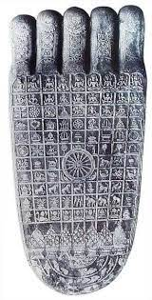

**Foot print of an ordinary person Foot print of the Buddha**

**Note: Another source** says: “when other persons set foot on the ground, the tip of the foot or the heel or the outer part of the sole touches the ground first, but the middle portion of the sole does not. But the Bodhisatta puts down his foot on the ground, the entire sole touches it evenly the way the sole of a soft golden shoe does…”[79]

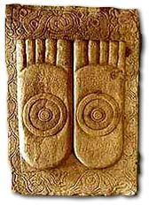

**The Buddha’s Feet [80]**

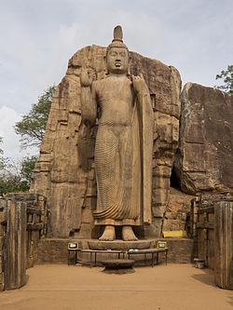

**Standing Buddha [81]**

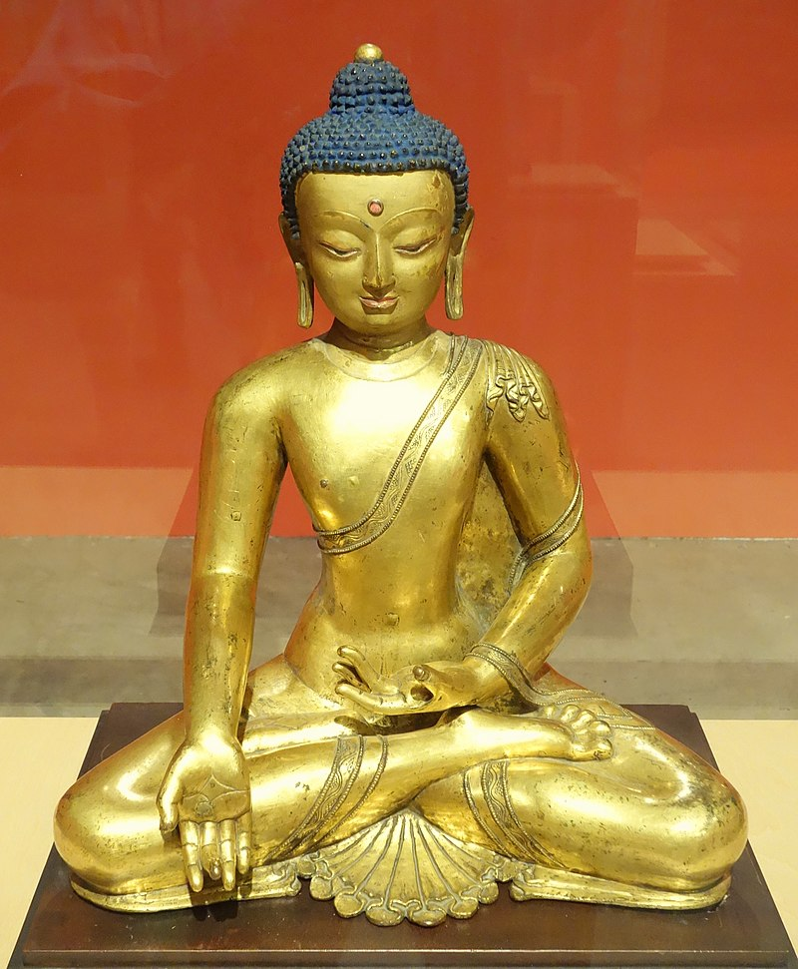

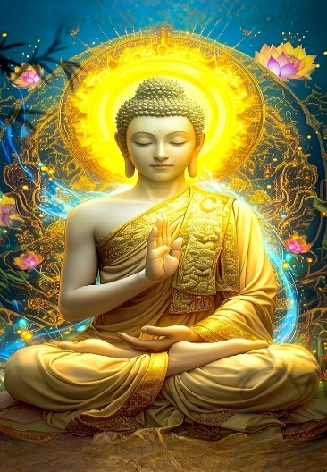

**Golden Skin colour of the Buddha [82]**

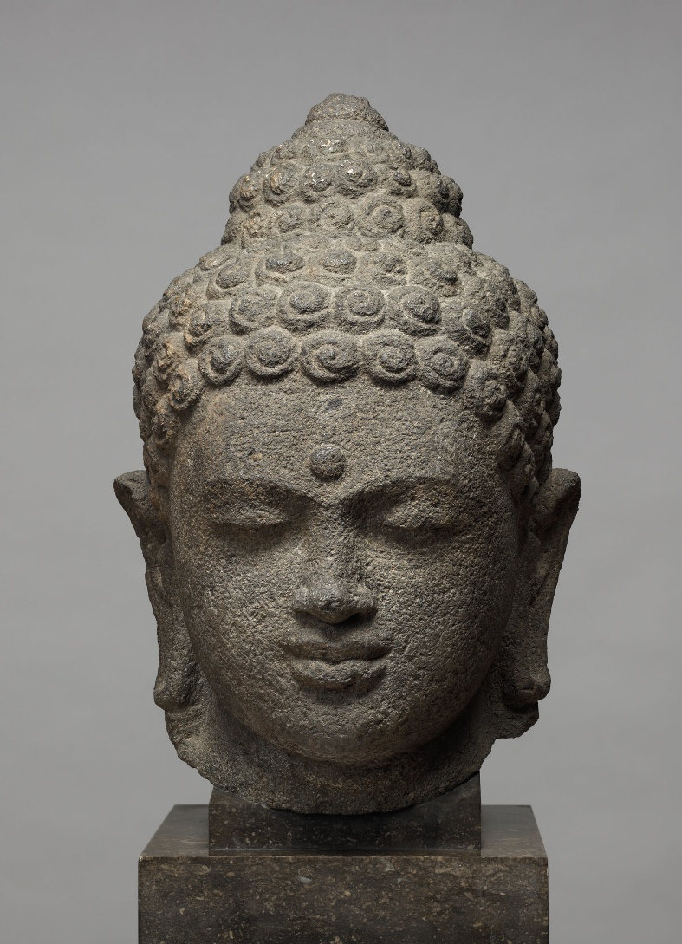

**The Buddha’s Head[83]**

In the next section (6) we will focus on theTitles and Epithets of the Buddha

### End Notes: Section 5

1. The Three worlds according to the scriptures are the Brahma world, the Deva world and the Human world. For more information: see: Introduction to DN: Cosmology: The Long Discourses of The Buddha by Maurice Walshe.
2. Source**:** divaina.lk Divaina News Paper, Colombi Sri Lanka
3. AN4: 77.
4. AN4: 23. * In AN4: 33, the Buddha compared himself to a lion.
5. Iti: 112 (Loka Sutta: Translated by Bhikhu Sujato, www.suttacentral.net)
6. MN: 12 (Mahāsīhanāda Sutta)* In AN10: 21, The Lion sutta also mentioned similar facts.
7. Majjima Attakatha explains this as the knowledge of the correlations between causes and their results. **See:** MN: Notes: 182, p. 1081.
8. An example of this knowledge is the Buddha’s analysis of kamma. See: MN: Notes: 183, p. 1081.
9. The Buddha’s knowledge of the paths leading to hell, the animal realm, the spirit world, the human world, the deva world, and nibbāna. See: AN: Notes: 1984.
10. See: MN: Notes: 187, p. 1082.
11. The “defilement” (sankilesa) is a state causing deterioration, “cleansing” (vodāna) a state causing excellence, “emergence” (vuṭṭāna) is both cleansing and the rising out of an attainment. The eight liberations (vimokkhā) are enumerated in MN 77.22 and MN 137.26; the nine attainments (samāpatti) are the four jhānas, four immaterial attainments, and the cessation of perception and feeling. MN: Notes: 188, p. 1082.
12. In MN: 4 (Bhayabherava Sutta) , the Buddha said: “…I recollected my manifold past lives, that is, one birth, two births, three births, four births, five births, ten births, twenty births, thirty births, forty births, fifty births, a hundred births, a thousand births, a hundred thousand births, many aeons of world-contraction, many aeons of world-expansion, many aeons of world-contraction and expansion: ‘There I was so named, of such a clan, with such an appearance, such was my nutriment…” Note: The Buddha can recollect 91 aeons back: see: SN: 42: 9.
13. This power is explained in MN: 4.
14. With this knowledge the Buddha can recognise the potential of persons who could benefit from his teachings, then he selects the suitable Dhamma subject which would help that person. If the **five faculties (***pancha iṅdriya)*: faith, energy, mindfulness, samādhi and wisdom are matured, a person can easily comprehend the Dhamma. **See**: KN: Patisambhidāmagga: ñāna katha
15. This refers to the understanding of mental dispositions and latent tendencies of a person and accordingly the Buddha delivers suitable teaching to them. **See**: KN: Patisambhidāmagga: ñāna katha.
16. This is a unique event in the life of the Buddha where he created two opposite elemental characteristics. On that occasion the Blessed One produced fire from the one part of the body and water from the other part of the body. Six coloured rays emerged from every pore. **See**: KN: Patisambhidāmagga: ñāna katha.
17. Through this knowledge the Buddha has great compassion for the welfare of all beings. He sees beings who are immersed in the flood of samsara and extends his unlimited support to help them cross over and be free. This is the reason the Buddha is called ‘the Great Compassionate One’. **See**: KN: Patisambhidāmagga: ñāna katha.
18. This is called ‘all-knowing’—the Buddha possessed the knowledge of everything that he needed to know about living beings and the world, therefore he is called ‘the Omniscient One’ (Sarvangnna). With this knowledge the Buddha has the ability to direcrt his mind to any object he wished to know. **See**: KN: Patisambhidāmagga: ñāna katha.
19. This means without any obstruction the Buddha can understand everything,.Patisambhidāmagga says that this and the knowledge of Omniscience are linked together. **See**: KN: Patisambhidāmagga: ñāna katha.
20. AN11:11
21. Recollection of the Buddha: *araham sammā-sambuddho, vijjā-carana-sampanno sugato lokavidū, anuttaro purisa-damma-sārathi satthā deva-manussānam buddho bhagavā*.”

    That Blessed One is such since he is accomplished, fully enlightened, endowed with [clear] vision and [virtuous] conduct, sublime, the knower of worlds, the incomparable leader of men to be tamed, the teacher of gods and men, enlightened and blessed.
22. Araham:rid of all impurities and defilements of the mind. Because of this quality the Buddha is worthy of receiving gifts and alms from any being in the world system.
23. Sammāsambuddho: the Fully Enlightened One who has discovered the Truth: four noble truths.
24. Vijjācaraṇa sampanno : he has the noble vision/knowledge and noble conduct. Through his vision he was able to destroy all taints and become liberated. He then guided other beings to free from samsara. The Blessed One’s conduct is noble and pure, harmless and beneficial to all beings.
25. Sugato: sublime one: one who has reached the right and highest destination—nibbana.
26. Lokavidū: The Buddha has the knowledge and the power to see the entire world system.
27. Anuttaro purisa-damma sārathi : The Buddha is the unparalleled leader who has the ability to tame beings who wish to be tamed.
28. Satthā Deva-manussānam: The Blessed One is the teacher, the guide/instructor to all beings of the Three Worlds who desire to be free from suffering.
29. Buddho: The Blessed One is awakened, awakened from the world immersed in darkness (ignorance). In MN:92 (the Sela sutta) , the Buddha said thus: “What must be known is directly known, what must be developed has been developed, what must be abandoned has been abandoned, Therefore, brahmin, I am a Buddha.”
30. Bhagavā: the Buddha is the supreme being with noble qualities, most fortunate and liberated being; he was fortunate to escape from samsara and showed the way of escape for all other beings, so he is called the fortunate one.
31. AN:11: 11.
32. AN4: 35.
33. Ibid.
34. Ibid.
35. SN: 6: 2.
36. Source: **:** Budusarana News Paper, Sri Lankahttps://www.budusarana.lk/budusarana/
37. VP:Mahākhandaka: 12 The account of the wonders at Uruvelā: translated from Pali by Bhikkhu Brahmali
38. AN:8: 11.
39. AN4:22.
40. AN:3: 15.
41. SN1:74.
42. MN: 108 (Gopakamoggallāna Sutta)
43. SN51: 22.
44. See: DN: 2 (Sāmaññaphala Sutta, para: 87) **Note**: The following suttas also described the powers: DN: 11 (Kevadda Sutta)  & DN:12 (Lohicca Sutta) and MN: 77 (Mahasakuludayi Sutta) & SN: 51:Iddipadasmyutta suttas.
45. Source: Kagyu Shenpen Kunchab Buddhist Centre

    <https://nobletruth.org/>
46. SN51: 22 .
47. Source: “The Life of the Buddha in Pictures”: Dhammatalks.net
48. VP: Mahakhandaka:12: The account of the wonders at Uruvela: translated from Pali by Bhikkhu Brahmali. * It says that the Blessed One performed ‘three and a half thousand wonders.’.
49. The three brothers became disciples of the Buddha with their students; listening to the Adithha Pariya Sutta—the fire sermon in SN: all of them became arahants. Details of the event is given in Section13-B (45 years of the Blessed One’s Life).
50. VP: Mahakhandaka: 12.
51. Iddhi-pāṭihāriya: ‘miracle of iddhi’- psychic powers.
52. Able to read the minds of other beings, their mental states, their thoughts and ponderings: “That is how your mind is, that is how it inclines, that is in your heart.”
53. A monk gives instruction as follows: “Consider in this way, don’t consider in that, direct your mind this way, not that way, give up that, gain this and persevere in it.”. Then following the instructions, the disciple is able to be free from suffering.
54. Observation of Ven. Bhikkhu Bodhi, see: MN: Notes: 1166, p. 1169.
55. MN:123 (Acchariya-abbhūta Sutta).
56. “The thirty-two marks, enumerated … are the subject of an entire sutta in the Dı̄gha Nikāya,

    DN:30, *Lakkhaṇa Sutta*. There each of the marks is explained as the kammic consequence of a particular virtue perfected by the Buddha during his earlier existences as a bodhisatta” See: MN: Note: 851.
57. DN:14 (Mahapadana Sutta), here it gives a detailed description of the thirty-two marks attributed to the Buddha Vipassi.
58. It means flat feet.
59. Having the fingers all of the same length, and the toes likewise.
60. Reticulated.
61. With the ankle half-way up the calf.
62. Like Brahmā.
63. The backs of the four limbs, the shoulders and the trunk are well-rounded.
64. A hairy mole.
65. The 32 marks are also mentioned in the following suttas: DN:4, MN: 91 & MN:92.* In famous Narasiha Stanza chanted by Princess Yasodhara described the special signs attributed to a great man, See: Chapter 18: The Great Chronicles of Buddhas by Venerable Mingun Sayadaw.
66. See also: Snp:3.7 (with Sela, translated from Pali by Bhikkhu Bodhi)
67. Snp:5.1 Translated by Bhikkhu Sujato.
68. Ibid.
69. DN:4 (Sonadanda Sutta)
70. Snp:3.1 (Pabbaja Sutta, translated by Bhikkhu Sujato).
71. DN:30.
72. VP:Mahakhandaka:6, translated by Bhikkhu Brahmali.
73. DN:16 (Mahāparinibbānasutta Sutta)
74. Ibid.
75. AN3:63
76. MN:36.
77. DN:30
78. Ibid.
79. Chapter 1: Explanations of Thirty-Two Major Marks: The Great Chronicles of Buddhas by Venerable Mingun Sayadaw.
80. Source: Buddha Net.
81. Avukana Buddha Statue: Source: https://en.wikipedia.org/wiki/Avukana_Buddha_statue
82. Exhibit in the Berkeley Art Museum and Pacific Film Archive, 2625 Durant Avenue #2250, Berkeley, California, USA: Source: Source: https://en.wikipedia.org/wiki/Physical_characteristics_of_the_Buddha
83. Source: Harvard Art Museums/Arthur M. Sackler Museum, Gift of Alan J. and Suzanne W. Dworsky in honour of Robert D. Mowry: <https://hvrd.art/o/352933>